Blueshift Software Demo Portal

Getting Started Guide

Data Protector 340 Course

Based on Data Protector 10.10

Version 1.0

Document Release Date: October 2018

Table of Contents

Getting Started: 2

Direct link 2

How to sign up: 3

After login 4

Search for the Data Protector Offering 6

# Getting Started:

## Direct link

If the user has a Blueshift Software Demo Portal user name and password:

Go to the following link:

<https://www.mfdemoportal.com/>

## How to sign up:

To get started in the Stratus Software Demo Portal, you will need a login. If you already have a login, do so here.

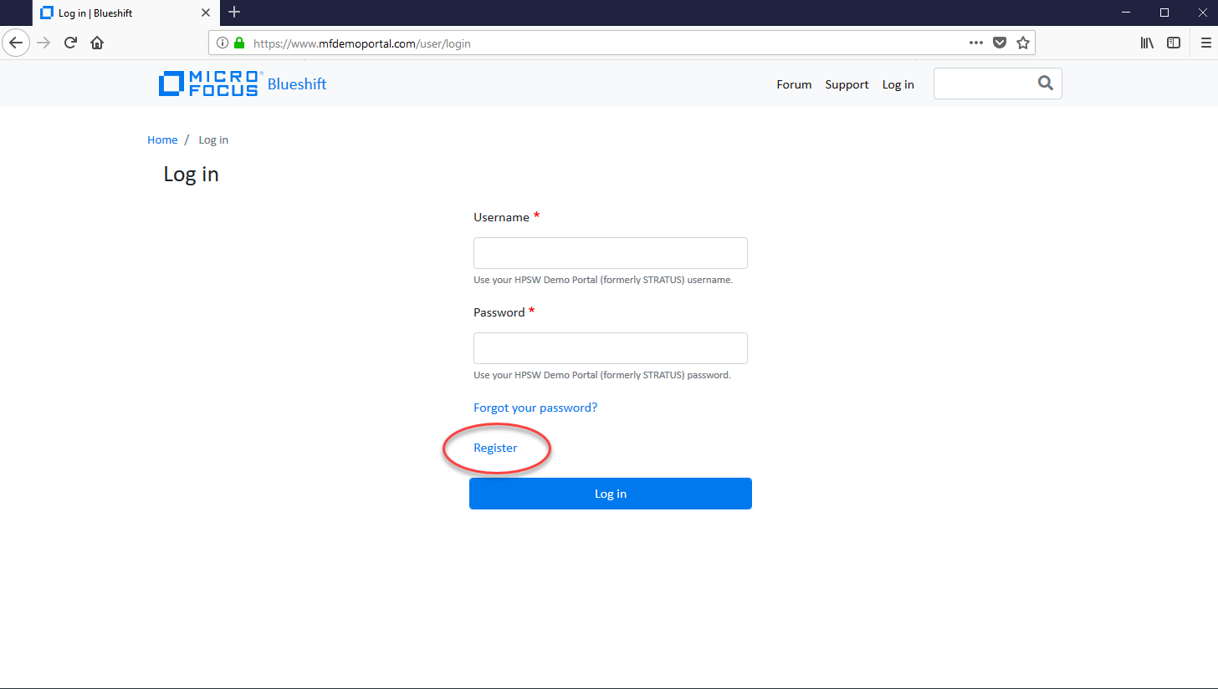

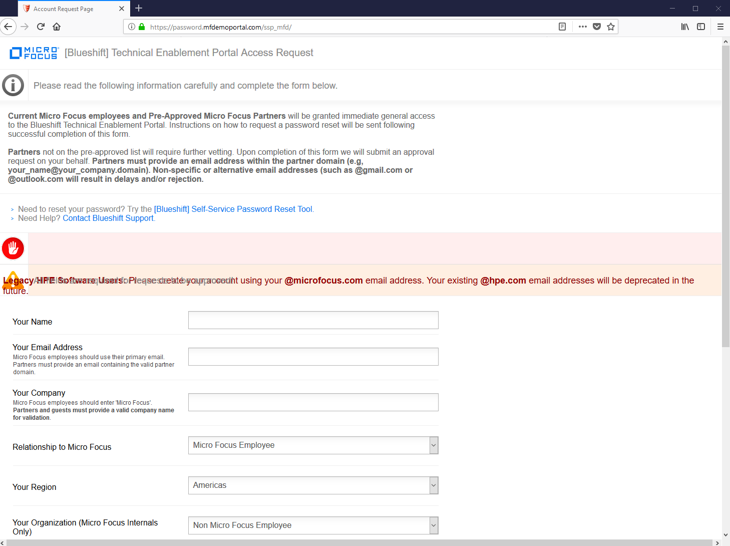

Fill out the form. Then, the system will send and email with your credentials once approved.

# After login

You should see this:

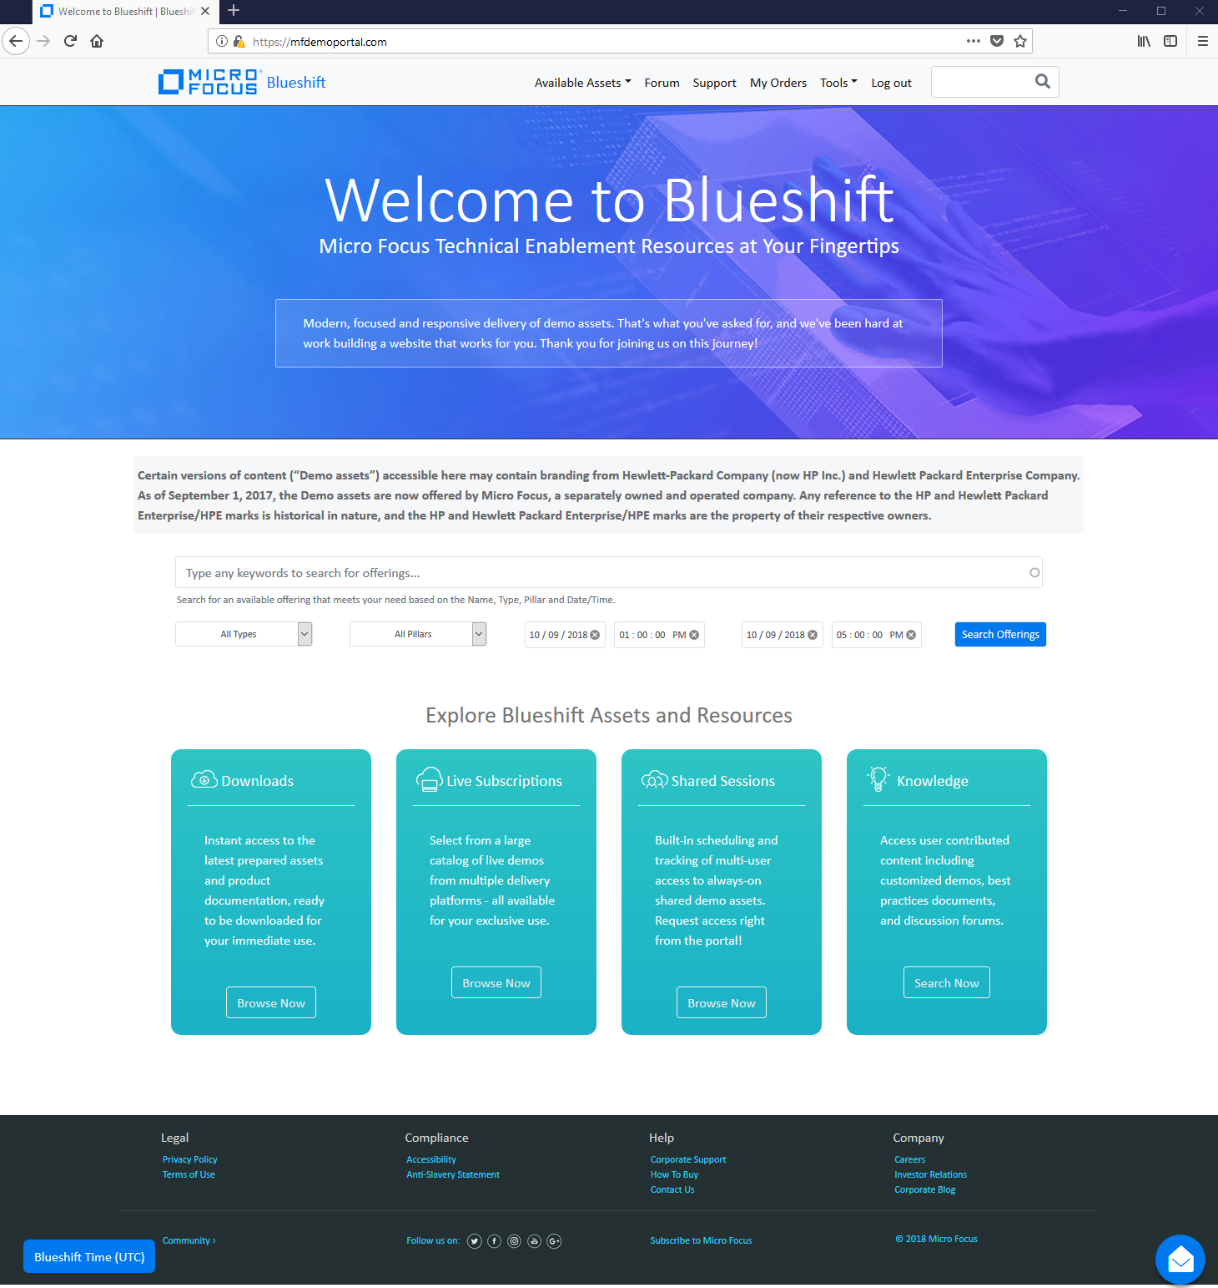

# Search for the Data Protector Offering

Put “Data Protector” in the Search Box and press “Search Offerings”

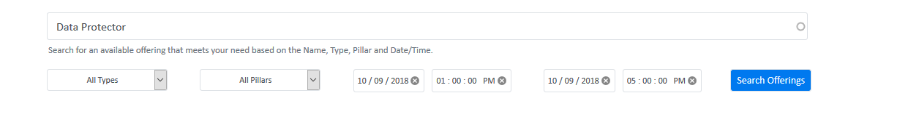

You will then see something like this:

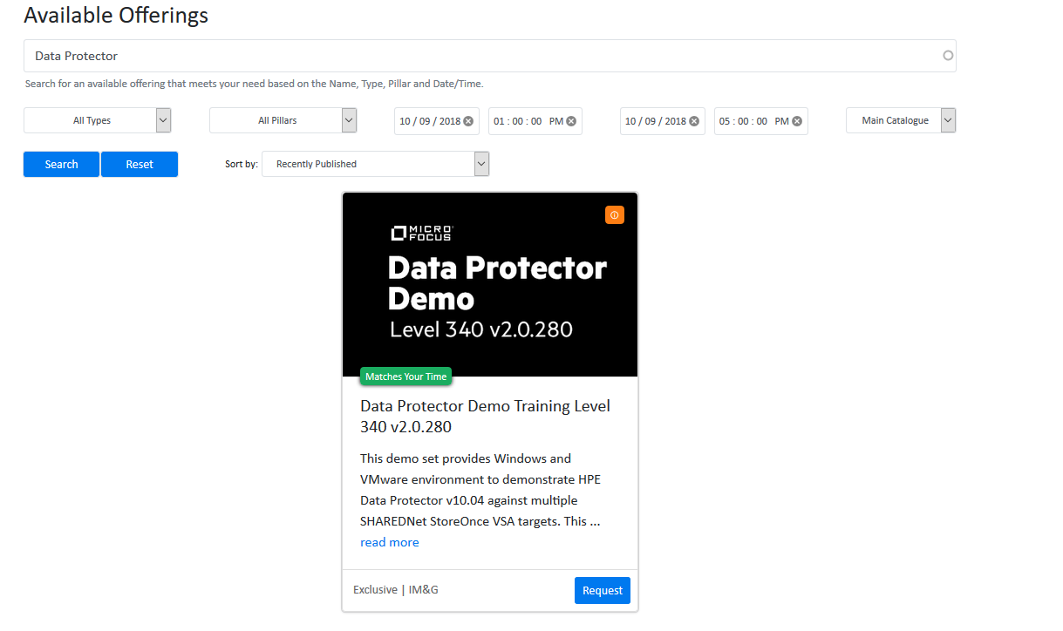

Note that the version you see after this search my be NEWER than than the one shown here.

After pressing “request” you should see this:

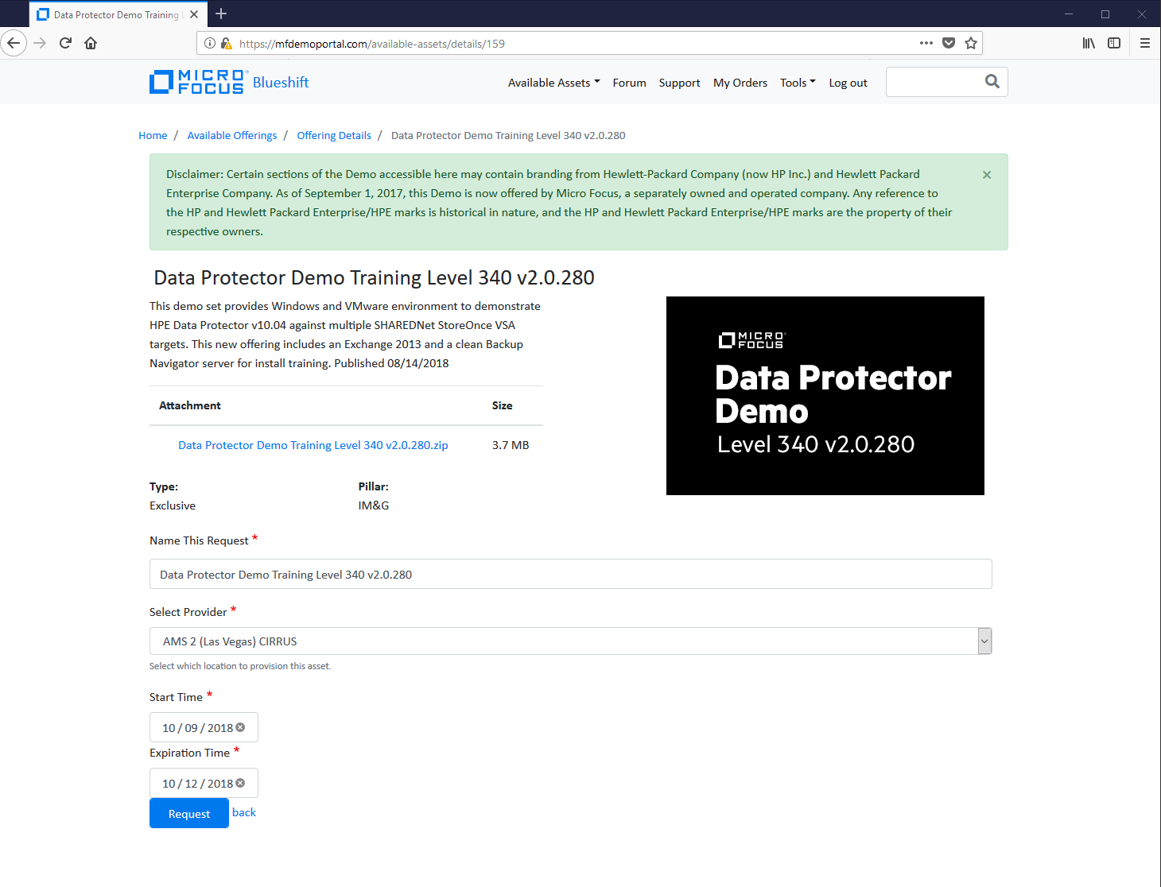

After requesting, you will get an email when your Demo environment is ready. The default time of the Demo is 3 days, but it can be extended.

The Demo will also come with a Demo Guide for both Data Protector and Backup Navigator (an optional product.)

Once in the environment, you should see something like this one pressing My Orders:

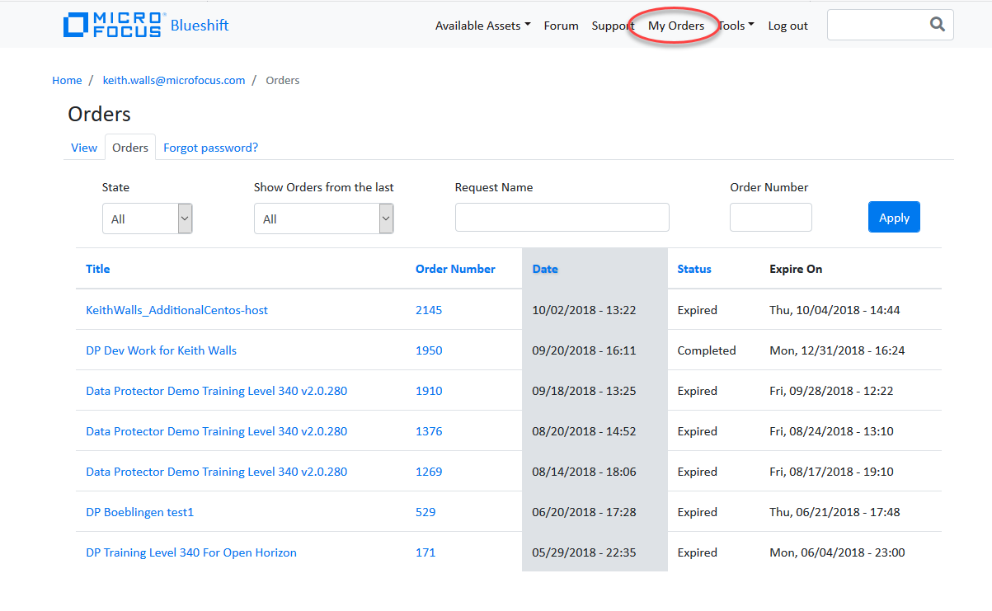

Then simply click on your current, active subscription, and you will get into the environment.

It will look something like this:

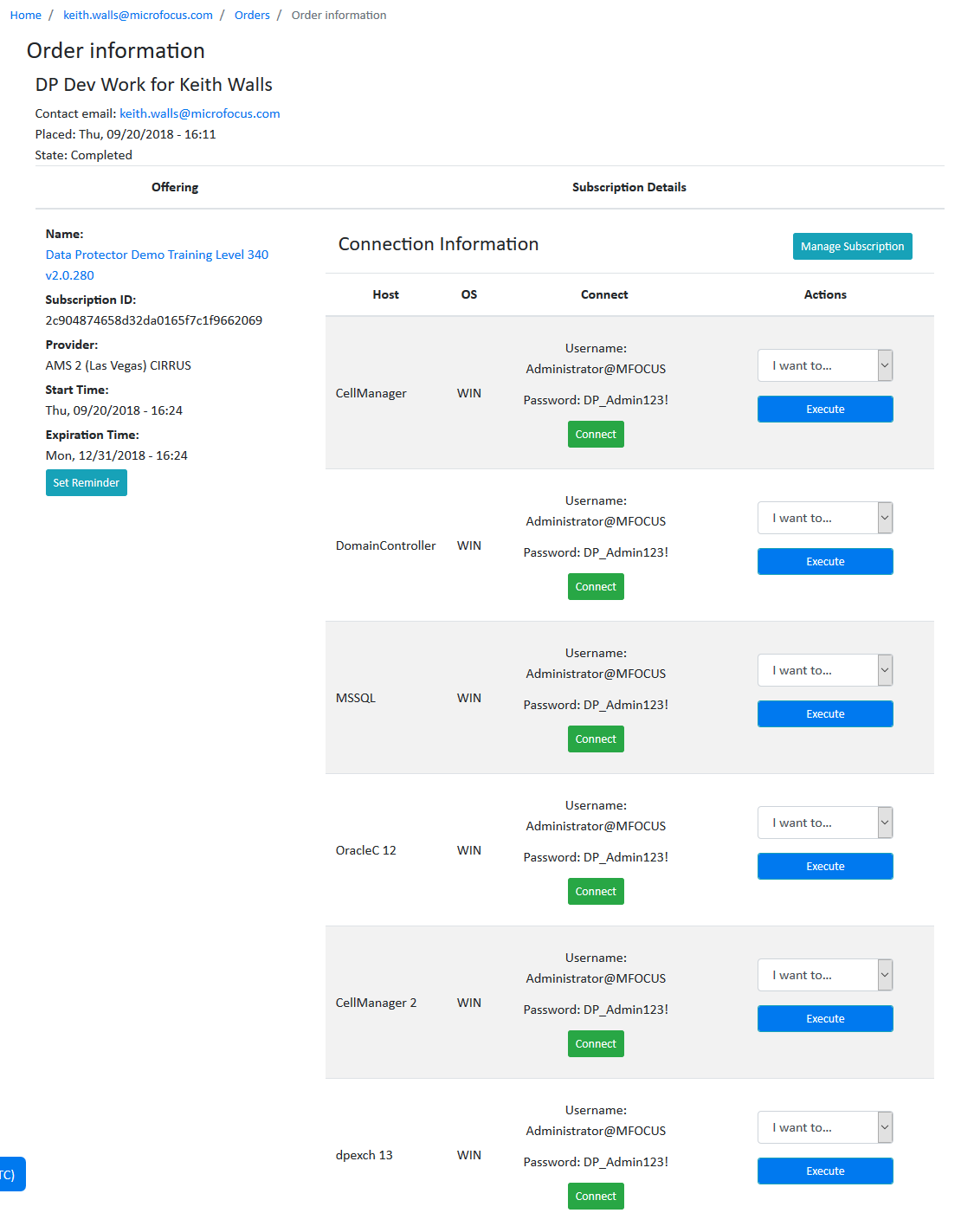

Please see the Demo Guide for more information after you get to this point. It is provided as an attachment to the Demo instance.